Smoke Free Policy (including Vaping)

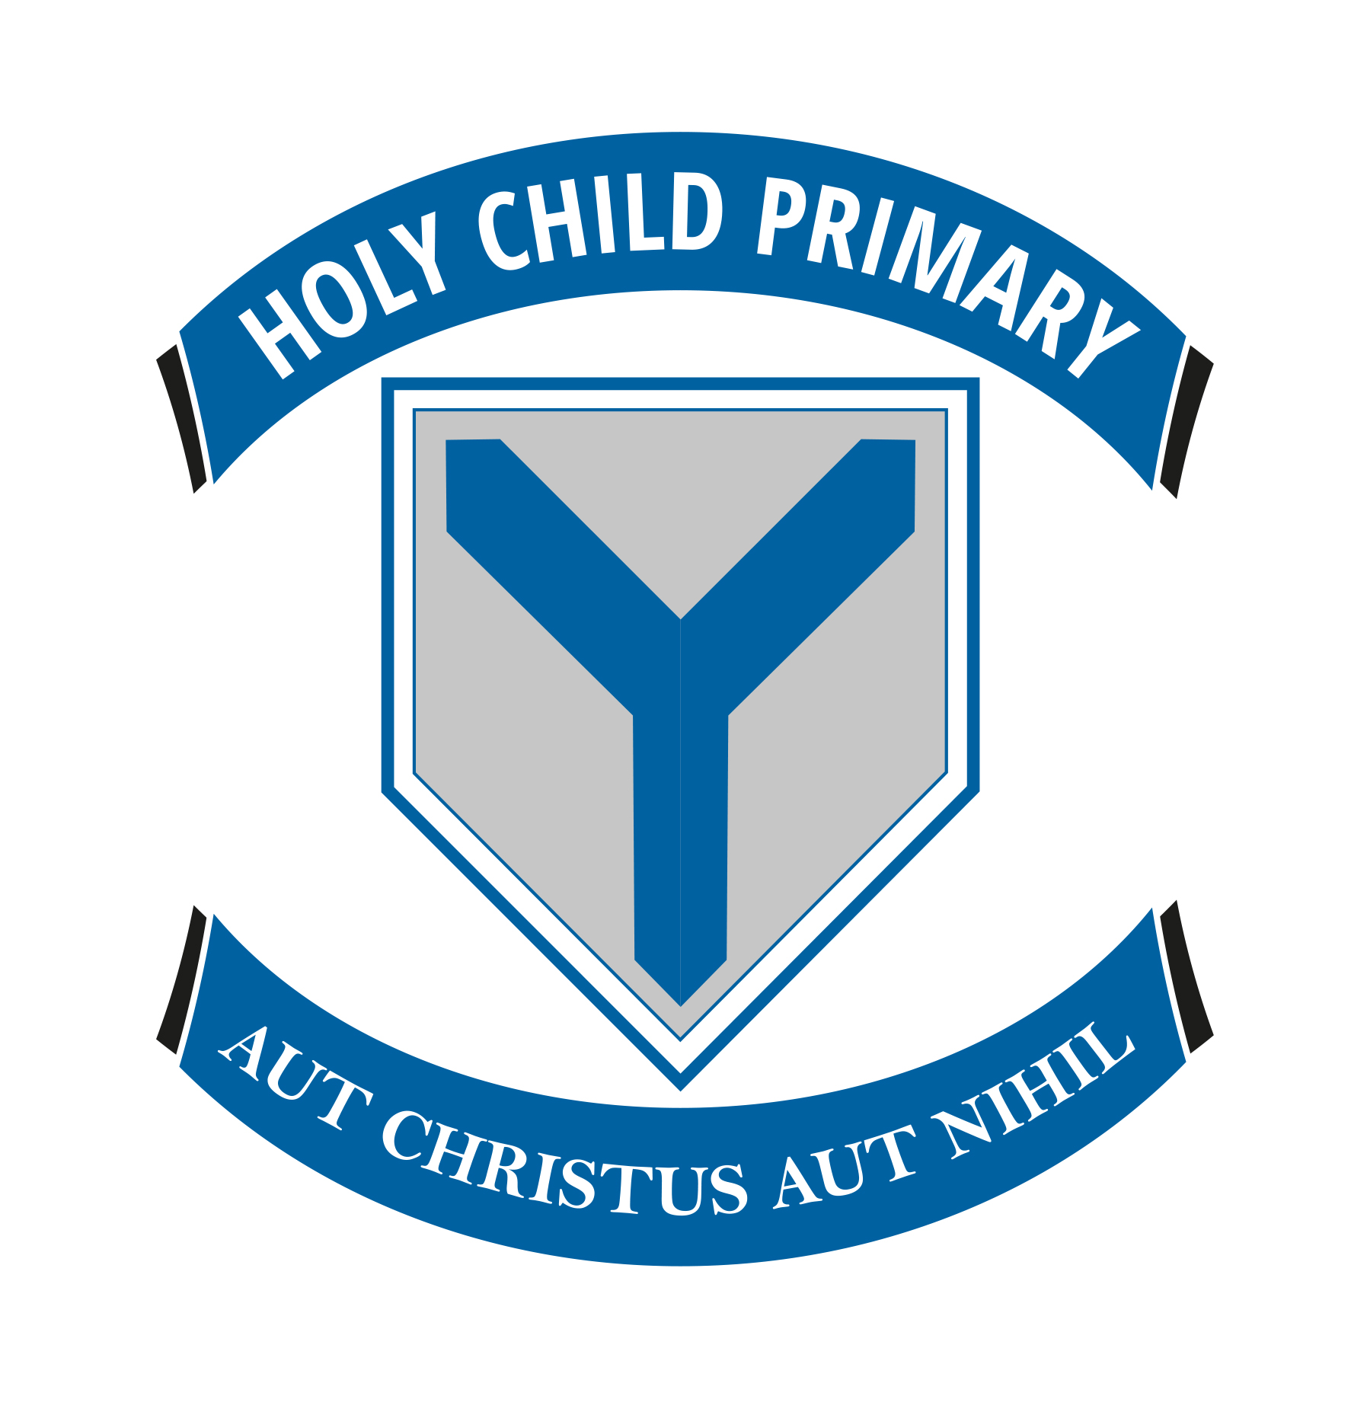

Holy Child Primary School

Belfast

(Updated March 2026)

POLICY FOR SMOKING/VAPING IN SCHOOL

Objectives

The objectives of the policy are:
• To provide an environment free of tobacco smoke or vaping.
• To protect children from inappropriate role models.
• To discourage pupils from starting to use tobacco or vapes.

The main element of the policy is that non-smoking should become the norm on school premises, at all times, and applied to all people.

Rationale

There are two grounds for creating a non-smoking policy in school:

- To protect all employees, pupils, parents and visitors from exposure to second-hand smoke and to comply with the Smoking (Northern Ireland) Order 2006 which is enforced by District Councils. The S.E.E.L.B. and the Governing Body have a duty to provide a safe environment. Tobacco smoke is harmful and therefore an environment contaminated with tobacco smoke could be regarded as unsafe. Studies have shown that smoke is harmful to the health of smokers and non-smokers alike. This consideration applies to school premises, and can be seen as a strong justification for creating a smoke-free environment.

- Role model. Staff in the school should act as role models to pupils and this is the argument that extends a non-smoking regime from school premises – in other words the buildings – to the school site, which includes the outdoor areas of the school. It is not a good example to have staff smoking or vaping outside the school, with the attendant litter problem.

Non-smoking area

The site, premises and buildings, including all temporary structures that form part of Holy Child Primary School, such as the school gate, are designated as non-smoking areas. The smoking of tobacco or tobacco products in any form is not permitted.
This policy applies to everyone on or using the school site: Staff, parents, pupils, visitors and anyone hiring the school building for meetings, functions etc;
New staff joining the school will be informed about the policy as part of their induction process. Signs indicating that the school site is a non-smoking area are displayed at all entrances to the site and in the school buildings. Staff who smoke/vape should do so at a designated area outside of school premises, out of sight from pupils.

Policy

It is the policy of Holy Child P.S that all of our school buildings and vehicles are smoke-free and all staff, pupils, contractors and visitors have a right to a smoke-free environment. The policy shall come into effect on March 2026 and be reviewed on annually by the Principal and the Board of Governors.

Premises

Smoking is prohibited throughout the entire school premises. Staff who smoke/vape should do so at a designated area outside of school premises, out of sight from pupils.

Vehicles

All school vehicles will be smoke-free at all times. Any member of staff using their car in connection with school activities (including giving a lift to a staff colleague or pupil to a meeting or other event) should not smoke for the duration of the journey.

Principal’s Duties:

- To display statutory No Smoking Signs at all main entrances to school buildings as required by the legislation;
- To ensure staff, pupils, contractors and visitors do not smoke in smokefree places and vehicles;
- To investigate complaints regarding staff, pupils, contractors and visitors smoking or vaping;
- To inform staff, pupils, contractors and visitors on this policy;
- To ensure that a written record of any incidents of smoking and how they were dealt with are kept.

Staff Duties:

- To ensure that they or others do not interfere with no smoking signs;
- To comply with the school’s Smoke-Free Policy;
- To ensure that parents, pupils, contractors and visitors do not smoke in our smoke-free school and vehicles;
- To report incidents of smoking in smoke-free areas and vehicles;
- To refrain from smoking if using their own vehicle to transport pupils in connection with school activities.

Parents’, Pupils’, Contractors’ & Other Visitors’ Duties:

Parents, pupils, contractors and visitors are not permitted to smoke or vape in smokefree areas, or school vehicles.
Parents using their own vehicles for school purposes e.g. transporting pupils to a sporting event are asked not to smoke for the duration of the journey.

Links to Drug Education

Tobacco is a drug and therefore there will exist a number of opportunities to link the adoption of a school smoking policy to drug education (see the ‘Policy for Drugs). Adopting both policies into the school’s practice will ensure that drug and smoking concerns are sufficiently covered.

Help for those who Smoke
This policy is not intended to stop people smoking but to regulate where they smoke and how it affects others. To help smokers adjust to the changes occurring they should contact the smokers helpline on 0800 858585 who can advise of local support services.

Policy Implementation

Members of staff will be given a copy of this Policy which will become part of their contract.
Parents will be informed of the Policy.
Members of staff have a duty of care to inform school visitors of the Policy.
Signs and notices shall be posted in prominent positions throughout the school premises.

Enforcement of this Policy

Failure to comply with this policy will be dealt with through the school’s disciplinary procedures. Visitors or members of the public who breach the policy will be asked to stop smoking and will be asked to leave the premises if they fail to comply with this request. All breaches of this policy will be recorded in writing by the school. Be aware that, in addition to action taken under this policy, the district councils may take legal action against individuals who smoke or vape in smoke-free places or vehicles.

Monitoring and Review

The policy will be reviewed annually by the Principal and Senior Management Team in consultation with the staff and a report made to the Governors.

Parental Consultation occurred with a focus group made up from parents from P6A and P2B in February 2026. The parents responded as follows

Child’s Class4 responses
Primary 2B | 3
Primary 6A | 1
Have you reviewed the policies provided?4 responses
Yes | 4
Partially | 0
Not yet | 0
4Overall, how clear do you find the updated policies? (1 = Not clear, 5 = Very clear)4 responses
Value | Count
1 | 0
2 | 0
3 | 0
4 | 0
5 | 4
Do you feel the policies are appropriate and effective? (1 = Not effective, 5 = Very effective)4 responses
Value | Count
1 | 0
2 | 0
3 | 0
4 | 2
5 | 2
Comments or suggestions on any policy (optional)
Please use this space to share any feedback on any of the following:
- Addressing Bullying Type Behaviour
- Drug Education Policy
- First Aid Policy
- Health & Safety Policy
- Parental Code of Conduct Policy
- Parental Complaints Policy
- Smoke Free Policy (including vaping)
2 responses
The policies are clear and comprehensive. However, the bullying behaviour policy would benefit from further clarification regarding the rights of a person experiencing bullying, particularly their right to defend themselves in situations involving physical violence.
Addressing bullying type behaviour policy. In the interventions 1-4 there is not much mention of what steps the school are taking with the pupil displaying the bullying type behaviour. I think this needs to be included and explained. Also there should be a procedure where the child's new teacher (following the summer break) is made aware of the previous bullying type behaviour... Especially if it is between pupils of the same class. Potentially even a meeting on the first week of school to check if anything happened over the summer break and/or if any reasonable adjustments are required in the classroom.
Do you feel this consultation gives parents a meaningful chance to contribute?4 responses
Yes 3
No 0
Unsure 1

