Health and Safety Policy
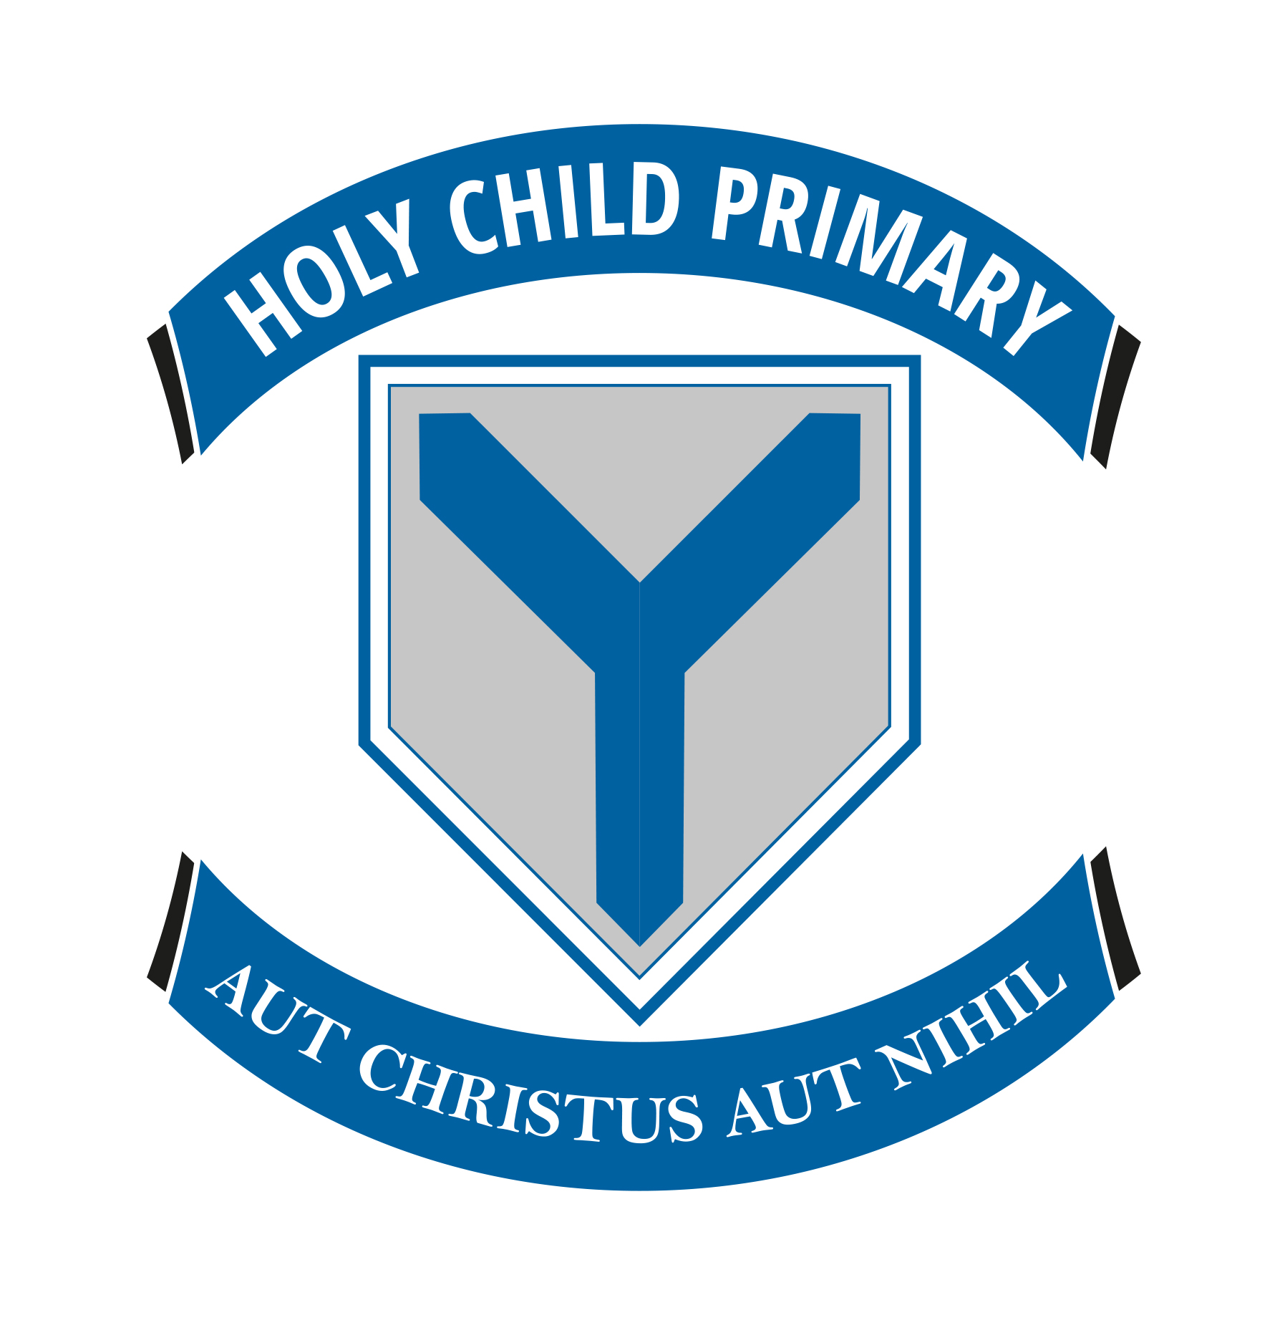

Holy Child Primary School
Belfast

(Updated March 2026)

Policy Objective:
The objective of this Policy is to ensure, so far as is reasonably practicable, that no person is placed in a position where injury or ill health is caused as a result of the Board of Governors’ undertaking.
1.The Board of Governors of Holy Child Primary School recognises and accepts its responsibility for Health & Safety as an employer, and in particular the duties laid down in Article 4 (Employers’ Duties) of the Health & Safety at Work (Northern Ireland) Order 1978 and all subsequent legislation made under that Order.
It also recognises and accepts its duties laid down in Articles 5 and 6 of that Order to persons other than its employees.

2. The Board of Governors will take all reasonably practicable steps to meet this responsibility for its employees under the terms of Article 88 of the Education and Libraries (Northern Ireland) Order 1986.

3. Where reasonably practicable, the Board of Governors will pay particular attention to the provision and maintenance of:- (i) a safe place of work, safe access to it and safe egress from it; (ii) plant, equipment and systems of work that are safe; (iii) safe arrangements for the use, handling, storage and transport of articles and substances; (iv) sufficient information, instruction, training and supervision to enable all employees to avoid hazards and contribute positively to their safety and health at work; (v) a healthy working environment; and (vi) adequate welfare facilities.

4. The Board of Governors will, so far as is reasonably practicable, provide and maintain up to date information for all staff on the potential hazards of substances and equipment used at work.

5. Without detracting from the primary responsibility of the Boards of Governors, Principals and Supervisors for ensuring safe conditions of work, the Education Authority, where reasonably practicable, will provide competent technical advice on safety and health matters where this is necessary to assist its management in its task.

6. The Board of Governors will co-operate fully in the appointment of safety representatives for its staff and will provide them where appropriate with sufficient facilities and training to carry out this task. The Board of Governors will co-operate fully where requested in the setting up of a safety committee.
7. The Board of Governors reminds its employees of their duties under Article 8 of the Health and Safety at Work (Northern Ireland) Order, 1978, to take reasonable care for their safety and that of other persons and to co-operate with the Board of Governors, so as to enable it to carry out its responsibilities successfully.

8. A copy of this statement will be issued to all employees. It will be reviewed, added to or modified from time to time and may be supplemented in appropriate cases by further statements relating to the work of particular workers or groups of workers.

Board of Governors

The Board of Governors of Holy Child School has a statutory responsibility under the Health and Safety at Work (Northern Ireland) Order 1978, for ensuring that the Board's Safety Policy is both understood and implemented in schools under their control and that risk assessments are carried out to address significant risks.

In the discharge of their statutory responsibilities Governors must ensure: -
- that all teaching staff recommended for appointment by them hold appropriate qualifications both to teach the subjects required of them and to use the necessary equipment and/or machinery;
- that both teaching and non-teaching staff are provided with regular training that will assist them to work safely;
- the maintenance of procedures for the safety of both teaching and non- teaching staff under their control;
- the maintenance of procedures for the safety of all persons using the premises under their control;
- the prompt and efficient maintenance of all equipment and all non-structural repairs as defined in the relevant Annex to the Common Funding Scheme for the Local Management of Schools;
- that contractors who are carrying out work on behalf of the Board of Governors, carry out their undertakings in a safe manner, so as to ensure the health and safety of all personnel on the premises;
- that all equipment and materials either purchased or acquired by them are suitable and safe for their intended use.

Principal
Principals of schools are responsible for the day to day application of this Health and Safety Policy both for teaching and non-teaching staff.
In the discharge of this responsibility each Principal shall: -
- ensure that all teaching staff hold appropriate qualifications both to teach the subjects required of them and to use the necessary equipment and/or machinery;
- ensure that all members of staff are provided with regular training that will assist them to work safely;
- ensure the provision and maintenance of procedures for the safety of all members of staff who come under their control;
- ensure that all staff are aware of any instructions or safety advice pertaining to all duties, issued by either the Board or the Department of Education;
- ensure that all safety reports pertaining to the school are understood and that the detailed work has been completed;
- ensure that adequate arrangements exist for carrying out regular fire drills and that all staff participate in and are aware of such arrangements;
- report to the Board of Governors, all defects and hazards which are its responsibility;
- ensure that safe systems of work are used by contractors or persons carrying out inspections or non-structural repairs, which are the Governors’ responsibility, as set out in the Scheme for the Local Management of Schools;
- report to the Education Authority all defects and hazards which cannot be dealt with under the Scheme for the Local Management of Schools;
- ensure that all significant accidents are reported promptly to the Board of Governors and to CCMS; and
- ensure that all staff operate safe working practices in the execution of their duties. In the absence of the Principal, the Acting Principal, the Vice Principal or the nominated senior teacher will assume the above role.
Leadership Team

The Leadership Team members are responsible for implementing the Board of Governors’ policy on Health and Safety. In the discharge of their responsibilities they will be responsible for: -
- ensuring that all significant risks within their areas of responsibility are assessed as required by regulation 3 of the Management of Health and Safety at Work Regulations (Northern Ireland) 2000;
- arranging for the full co-operation with the Board of Governors in the identification of hazards, and investigation of injuries;
- initiating action to rectify, where reasonably practicable, all defects and hazards which have been brought to their attention by the Board of Governors;
- consulting with the Board of Governors or other designated officer to identify Safety Training needs for all staff under their control;
- participating fully in the consultative processes established by the Education Authority for the purposes of Health and Safety;
- encouraging all staff to operate safe working procedures; and
- reviewing the effectiveness of the Health and Safety Policy in consultation with the Board of Governors.

Staff, Volunteers, Coaches, Students and Substitute Members of Staff

All staff, volunteers, coaches, students and substitute members of staff have a responsibility to exercise care and attention, regarding the safety of themselves and pupils under their control. In the discharge of this responsibility all staff, volunteers, coaches, students and substitute members of staff shall: -
- ensure that they take reasonable care during their work activities to avoid accidents or injury to themselves, other members of staff and pupils;
- observe all safety instructions and advice issued by either the Education Board or the Department of Education;
- observe all safety rules relating to specific equipment or processes;
- ensure that all protective clothing and equipment, as required, are both available and used by themselves and pupils;
- report all potential hazards affecting health and safety to the Principal or a member of the Leadership Team;
- obtain adequate treatment as soon as possible, if injured;
- report all accidents to the Principal and ensure that the Accident or Incident Report Forms are fully completed;
- co-operate fully with the Vice Principal and the Principal on all matters pertaining to Health and Safety;
- exercise effective supervision of pupils and know emergency procedures in respect of Fire, First Aid etc;
- know the special safety measures to be adopted in their own teaching area and ensure they are applied;
- give clear instructions and warnings as often as is necessary;
- follow safe working procedures personally; and
- make recommendations to the Principal or to and the Leadership Team, on the provision of safety equipment and on improvements to plant, tools or equipment, which are dangerous, or are potentially dangerous.

Non-teaching Supervisors, Cleaners and support staff

Those staff who have supervisory responsibilities are responsible for the practical application of the Health and Safety Policy and Safe Working Procedures. In the discharge of this responsibility supervisors shall: -
- encourage staff under their control to employ safe working practices and pay particular attention to the Health and Safety Policy;
- assist the Board of Governors to develop safe working practices and arrange for their adoption;
- instruct new employees in appropriate safety measures and the procedures laid down in the Health and Safety Policy;
- ensure that all defects in equipment or protective clothing are corrected and reported accordingly to the appropriate person;
- report all significant incidents and accidents involving injury, to the Principal; and
- furnish information as required in the investigation of injuries, accidents or incidents.

The Safety Officer

The Designated Safety Officer in Holy Child Primary School is Mr C Murphy (Principal).
The Board of Governors’ Safety Officer's responsibilities include the following: -
- advising the Board of Governors of the development and application of the school’s Health and Safety Policy and its Safety Programme;
- the interpretation of relevant Health and Safety legislation and Regulations in order that Holy Child Primary School complies with relevant legislation, within their scope of work;
- the interpretation of Codes of Practice issued under the Health and Safety at Work (Northern Ireland) Order 1978, so that all relevant Codes are adhered to and good safety practices are observed;
- the establishment and servicing of appropriate consultative processes, to be used as a forum for health and safety discussions with employees and provide assistance with the training of representatives appointed to such committees;
- the arrangements, in liaison with other specialist staff, for the inspection of buildings, plant and equipment so as to ensure that health and safety requirements are being met, and to identify hazards to health and safety and advise on measures to be taken to rectify them;
- the maintenance of accident statistics, advising on accident reporting procedures, processing accident reports and liaising with the Claims and Legal Section, the school's Insurers and all sections on claims for compensation arising from accidents to staff;
- the analysis of accident statistics and recommendation of health and safety measures to prevent their recurrence;
- devising and delivering, in conjunction with specialist officers, training programmes to educate staff in good safety practices;
- on behalf of the Board of Governors, communicating with the Health and Safety Executive on matters regarding health and safety at work.
- The Health and Safety at Work (Northern Ireland) Order 1978 states that a safety policy should be revised "as often as may be appropriate". This Health and Safety Policy will be reviewed every two years, or sooner, if amendments are required and will be revised as necessary.

Parental Consultation occurred with a focus group made up from parents from P6A and P2B in February 2026. The parents responded as follows

Child’s Class4 responses
Primary 2B | 3
Primary 6A | 1
Have you reviewed the policies provided?4 responses
Yes | 4
Partially | 0
Not yet | 0
4Overall, how clear do you find the updated policies? (1 = Not clear, 5 = Very clear)4 responses
Value | Count
1 | 0
2 | 0
3 | 0
4 | 0
5 | 4
Do you feel the policies are appropriate and effective? (1 = Not effective, 5 = Very effective)4 responses
Value | Count
1 | 0
2 | 0
3 | 0
4 | 2
5 | 2
Comments or suggestions on any policy (optional)
Please use this space to share any feedback on any of the following:
- Addressing Bullying Type Behaviour
- Drug Education Policy
- First Aid Policy
- Health & Safety Policy
- Parental Code of Conduct Policy
- Parental Complaints Policy
- Smoke Free Policy (including vaping)
2 responses
The policies are clear and comprehensive. However, the bullying behaviour policy would benefit from further clarification regarding the rights of a person experiencing bullying, particularly their right to defend themselves in situations involving physical violence.
Addressing bullying type behaviour policy. In the interventions 1-4 there is not much mention of what steps the school are taking with the pupil displaying the bullying type behaviour. I think this needs to be included and explained. Also there should be a procedure where the child's new teacher (following the summer break) is made aware of the previous bullying type behaviour... Especially if it is between pupils of the same class. Potentially even a meeting on the first week of school to check if anything happened over the summer break and/or if any reasonable adjustments are required in the classroom.
Do you feel this consultation gives parents a meaningful chance to contribute?4 responses
Yes 3
No 0
Unsure 1

