First Aid and Medication Policy


Holy Child Primary School

Belfast

(Updated March 2026)

First Aid and Medication Policy

Policy Statement
The Principal and Board of Governors of Holy Child Primary School accept their responsibility under the Health and Safety (First Aid) Regulations (Northern Ireland) 1982 and acknowledge the importance of providing First Aid for employees, children and visitors within the School.
The staff of Holy Child Primary School recognise their statutory duty to comply with the Reporting of Injuries, Diseases and Dangerous Occurrences Regulations (Northern Ireland) 1997 and agree to abide by the Education Authority’s (EA) procedure for reporting accidents. The DE document ‘Supporting Children with Medical Needs’ has provided clear guidelines in the compiling and implementing of this policy.

Introduction
‘First Aid is the initial assistance or treatment given to someone who is injured or suddenly taken ill’ (The Joint First Aid Manual 8th Edition). Staff administering First Aid should seek to assess the situation, protect themselves and the casualty from further danger, deal with any life threatening condition and where necessary obtain medical assistance or refer the casualty to hospital as quickly as possible.

The First Aid Policy at Holy Child Primary School is in operation to ensure that every pupil, member of staff and visitor will be treated appropriately, in the event of an accident, no matter how minor or major.

The First Aid boxes are located in the school office and in the staffroom. They are also located in P1, P2 and P6 with the designated first aiders. They are in labelled cupboards.

It is emphasised that the First Aid Team consists of qualified First Aiders and not trained doctors or nurses. The term FIRST AIDER refers to those members of the school community who are in possession of a valid First Aid at Work certificate or equivalent.

The purpose of the First Aid Policy is therefore:

- To provide effective, safe First Aid cover for pupils, staff and visitors;
- To ensure that all staff and pupils are aware of the Policy and the action(s) to be taken in the event of an accident: and
- To raise awareness of Health and Safety issues within school and on school trips and to prevent, where possible, potential dangers or accidents.

Statement of First Aid Provision
The School’s arrangements for providing First Aid will: -
- Place a duty on the Principal and Board of Governors to approve, implement and review the First Aid policy;
- Place individual duties on all employees;
- Report and record accidents in liaison with the Principal/Vice Principal and forward information to the EA/CCMS where appropriate;
- Record all occasions when First Aid is administered to employees, pupils and visitors;
- Provide equipment and materials to provide First Aid treatment;
- Make arrangements with EA to provide First Aid training to employees, maintain records of training and review annually;
- Establish a procedure for managing accidents in school which require First Aid treatment;
- Provide information to employees on the arrangements for First Aid;
- Undertake a risk assessment of the First Aid requirements of the school and review on a regular basis;
- Use the information from the risk assessment of First Aid to determine the number and level of trained staff and also any additional requirements (e.g. specialised training for children with particular medical needs);
- Notify parent/guardian that first aid treatment was given to the child.

A standard First Aid Kit will contain the following items:
Sterile adhesive dressings (assorted sizes)
Triangular bandages
Eye pads
Safety pins
Sterile wound dressings
Disposable gloves
Bandages
Anti-Bacterial Wipes
Burns dressings
Plasters
Ice Packs
Contents of the Kits will be checked each term.
Before undertaking any off site activities, the level of First Aid provision will be assessed by the Principal and a First Aid Kit will be taken by staff on the trip, along with any individual children’s Health Plans and/or medication boxes.
Information on First Aid Arrangements
The Principal will inform all employees at the school of the following: -
- The arrangements for recording and reporting of accidents;
- The arrangements for First Aid;
- Those employees who are qualified First Aiders;
- The location of the First Aid Kits.

All members of staff will be made aware of the School’s First Aid and Medication policy.

Epi and Jext Auto Injector Pens
The administering of pens must be carried out by the nearest member of trained staff in the event of an emergency and/or when the anaphylactic shock is apparent irrespective of whether piriton has been administered first
Children who have required injector pens or who suffer from allergens have their own medical/care plans.
These are available at the first aid station and secretary’s office.

Accidents involving bumps to a Pupil’s head
The consequence of an injury from an accident involving a bump or blow to a pupil’s head/face area is not always evident immediately and the effects may only become noticeable after a period of time.
In all cases the parent/guardian will be contacted and notified of the child’s injury. The parents will be invited to come to the school to assess the child’s injury for themselves. Where the child remains in school, the staff will monitor him/her in case of any deterioration.

Transport to hospital or home

The Principal will determine the appropriate action to be taken in each case. Where the injury requires urgent medical attention an ambulance will be called and the pupil’s parent or guardian will be notified. If hospital treatment is required, then the pupil’s parent/guardian will be called for them to take over responsibility. If no contact can be made with parent/guardian or other designated emergency contacts, then the Principal/Designated Adult may decide to transport the pupil to the hospital. Two adults will be present on all journeys to the hospital/home.

Where the Principal makes arrangements for transporting a child to his/her home/or hospital, then the following guidance will be adhered to: -
- No individual member of staff will be alone with the child in a vehicle; and
- A second member of staff will be present to provide supervision of the injured pupil.

ADMINISTRATION OF MEDICATION
Medication will only be administered on the school premises where and when it is deemed absolutely essential and after consultation between the Principal (Vice-Principal in his absence) and the parents/guardians of the child concerned.
When a request by a parent to administer medication to his/her child is received, the following procedure will be followed:
- Principal (Vice-Principal/Class Teacher) discusses request with Parent and if it is deemed appropriate in the short term/long term to administer the medication, a note will be taken of the name of the medication, dosage and the period of duration in the Medication Records Book (see Appendix 1). These notes are to be signed by the parent and will be retained by the Principal.

- The Medication will be clearly labelled by the parent and/or GP with the child’s name and dosage.

- The medication will be given by the parent/carer (NOT THE CHILD) to the Principal for safe storage. The only exceptions to this procedure are children who have a particular medical condition e.g. peanut allergy etc. and for whom individual arrangements are in place throughout the year.

- Details of all medication administered will be recorded in the Administration of Medicine Record Book which is kept in the Principal’s Office.

- Specific medical conditions which require ongoing /occasional medication should be noted appropriately on the School Information Sheet annually i.e. at the start of September or as soon as possible after diagnosis; e.g. Asthma Medications should be stored in a box/container which is clearly labelled and these are stored securely in the store of the child’s classroom. The child’s photographs, class and date of birth should be recorded on the lid of each box.

- Medication is never kept in any other area of the school in order to prevent it being used/consumed accidentally by another child.

Implementation of the First Aid and Medication Policy will be monitored by the Principal, Vice Principal in consultation with staff, parents and children. Feedback will inform amendments which will be incorporated appropriately.

FIRST AIDERS will:

- Ensure that first aid cover is available throughout the working hours of the school week and administer appropriate first aid when required;
- Always attend a casualty when requested to do so and treat the casualty to the best of their ability, in the safest way possible. This includes wearing personal protective equipment including gloves, especially where any loss of blood or body fluid is evident;
- Request help from other First Aiders and/or the Emergency Services when required;
- Help fellow First Aiders at the scene of an incident and provide support afterwards;
- Insist that any casualty who has sustained a significant injury is seen by a professional at the GP’s surgery or at the hospital, either by sending them directly to hospital or by asking parents to pick up a child to take them to the GP’s surgery or hospital. Parents will be notified promptly of all head injuries and all significant injuries;
- Ensure that a child who is sent to hospital by ambulance is either:
1. Accompanied in the ambulance at the request of paramedics;
2. Followed to the hospital by a member of staff to act in loco parentis if a relative cannot be contacted or is delayed; or
3. Met at the hospital by a relative.

The First Aider need not be the member of staff to accompany the casualty to hospital. However, an appropriate staff member will be nominated;
- Ensure that a record is kept, in the school’s Accident Book, of each pupil, staff member or visitor who has received First Aid, which details the nature of the injury and any treatment given; and
- Ensure that all first aid resources which have been used are disposed of appropriately.

The Board of Governors will:
- Provide adequate First Aid cover as outlined in the Health & Safety [First Aid] Regulations 1982 (N.I);
- Approve, implement and review the First Aid Policy;
- Monitor and respond to all matters relating to the health and safety of all persons on the school premises; and
- Ensure all new staff members are made aware of the First Aid Policy and Procedures in school.

The Principal will:
- Ensure that the school has a current information form for every pupil and staff member which indicates any specific conditions or medications, of which the school should be aware;
- Ensure that all staff members are made aware of the medical and/or First Aid requirements of staff and pupils (where relevant), are aware of the First Aid and Medication Policy and are also aware of the arrangements for recording and reporting accidents;
- Ensure that this First Aid Policy is implemented fully in St Mary’s Primary School;
- Ensure that there are signs displayed throughout the school with the following information – the location of the First Aiders and the First Aid Kits;
- Ensure through termly checks, that the school’s First Aid boxes are appropriately stocked and that all First Aid resources are “in date”;
- Ensure that First Aid training qualifications are current and are renewed when required;
- Ensure that, in the event of injury, the injured party must be referred to a First Aider for examination and where necessary, to parents and/or to relevant professionals;
- At the start of each academic year, provide the First Aid Team and all relevant staff, with a list of pupils who are known to have any significant illnesses or conditions;
- Ensure that the defibrillator is checked on a weekly basis to ensure that it is in working order and that a record of these checks is maintained;
- Maintain a file of up to date medical health plans and relevant medicines and ensure that these are readily available for staff members and for staff responsible for school trips/outings;
- Ensure, where possible, that the relevant staff members are trained in relation to the administration of medication which may be required by specific pupils or staff members with medical conditions;
- Ensure that records of all First Aid training are maintained;
- Ensure that all classes are supervised in the event of a class teacher being absent from class, as the result of a First Aid incident; and
- Report any significant “First Aid” incidents to the relevant authorities (where appropriate).

STAFF MEMBERS will:
- Familiarise themselves with the school’s First Aid and Medication Policy and will ensure that they are aware of who the current First Aiders are;
- Be aware of the specific medical needs of particular individual pupils and attend relevant training in relation to these medical needs;
- Never move a casualty, until they have been assessed by a qualified First Aider, unless the casualty is in immediate danger;
- Send for the help of a First Aider when an injury occurs, as soon as possible, either by a person or telephone, ensuring that the messenger knows the precise location of the casualty. Where possible, confirmation that the message has been received must be obtained;
- Accompany a pupil who has a minor injury to a First Aider (where appropriate);
- Send for an ambulance when a significant accident occurs; and
- Have due regard for personal safety at all times.

The implementation of this Policy will be monitored by the First Aid Team, the Principal and the Governors. This Policy will be reviewed every two years, taking into account new initiatives, changes in the curriculum, changes in the law and/or changes to the First Aid Team in Holy Child Primary School.

APPENDIX 1

Staff Trained in First Aid – Updated December 2025

Nursery | Kathy Graham
Primary 1 | Amy McCullough
 | Tracey Brown
 | Aiveen Varndell
Sunshine Room | Deirdre Rafferty
Primary 2 | Shauneen McCallin
 | Dearbhaile Woods
Primary 3 | Rebecca McLaughlin
Primary 4 | Sinead Notara
Primary 6 | Aisling O’Neill
 | Emer McNally
 | Michael McCloskey
Primary 7 | Ursula O’Neill
 | Brenda Quinn
 | Therese McGreevy
 | Paddy Ryan
 | Holly Reid
 | Ciara McKernan
Office | Sharon McKernan
 | Sophie Copeland
APPENDIX 2 REQUEST FOR SCHOOL TO ADMINISTER MEDICATION
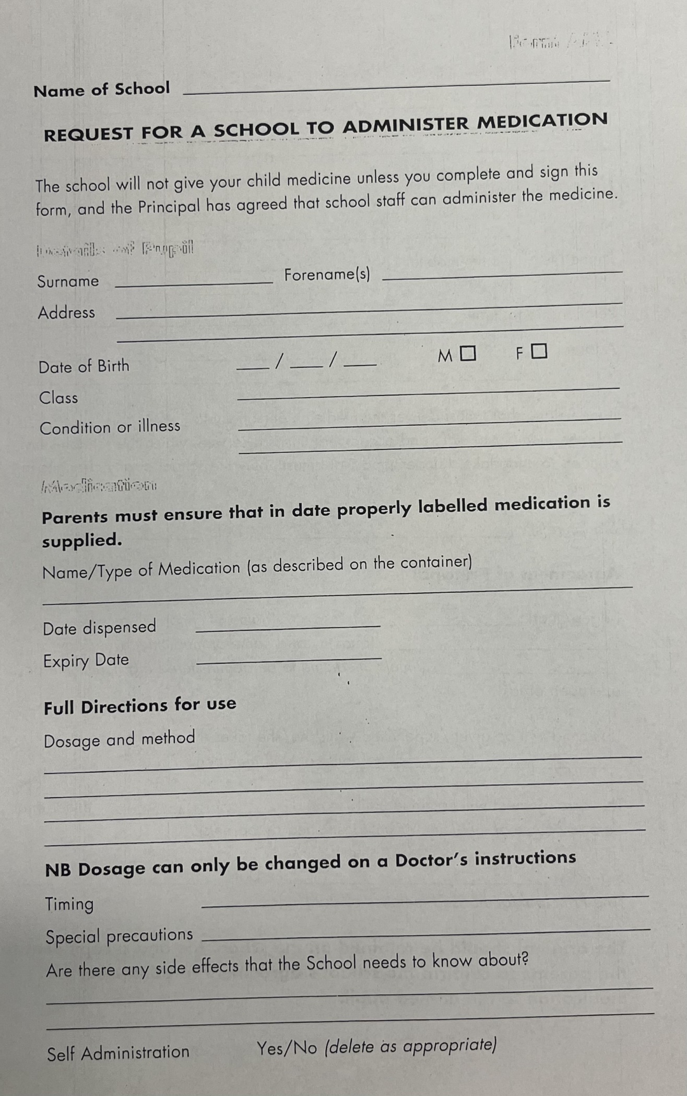
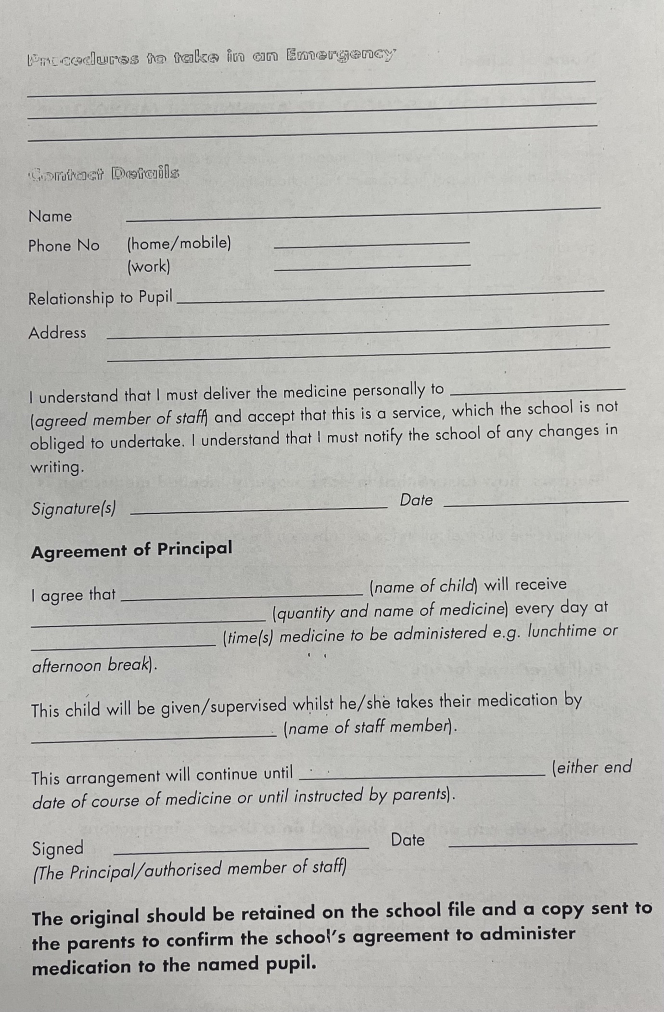
APPENDIX 3 ACCIDENT INJURY REPORT FORM
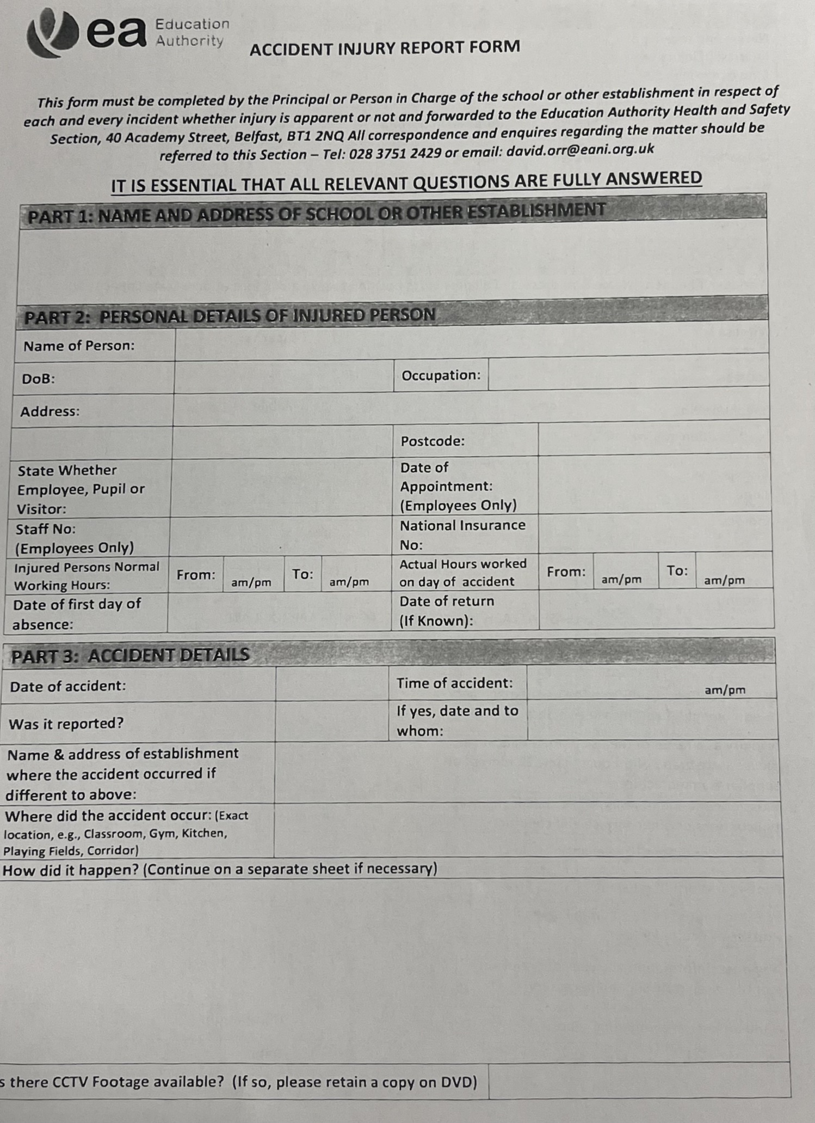
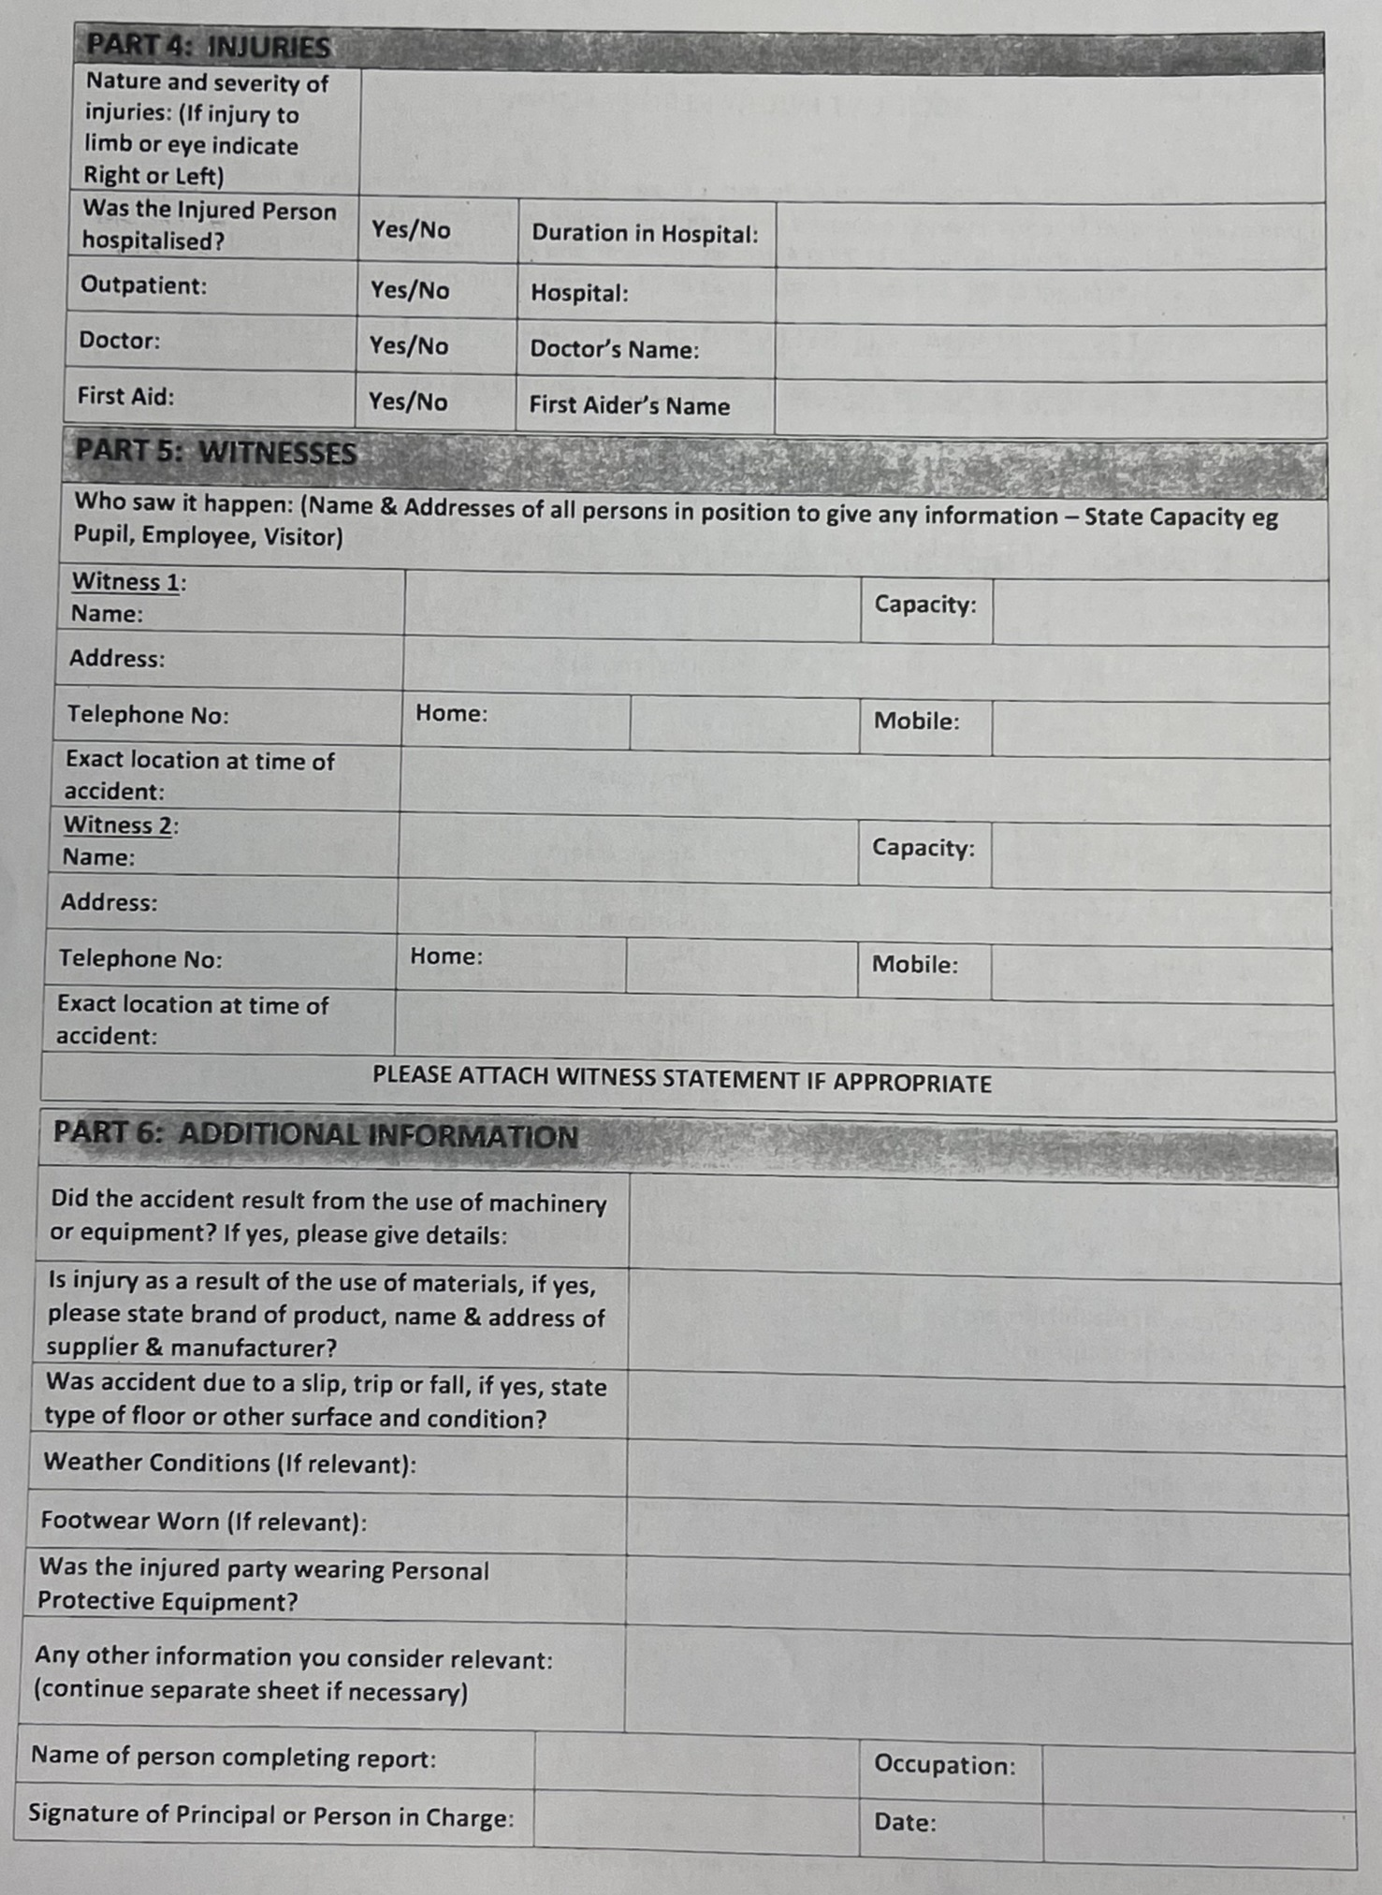

APPENDIX 4 SPECIAL DIET APPLICATION FORM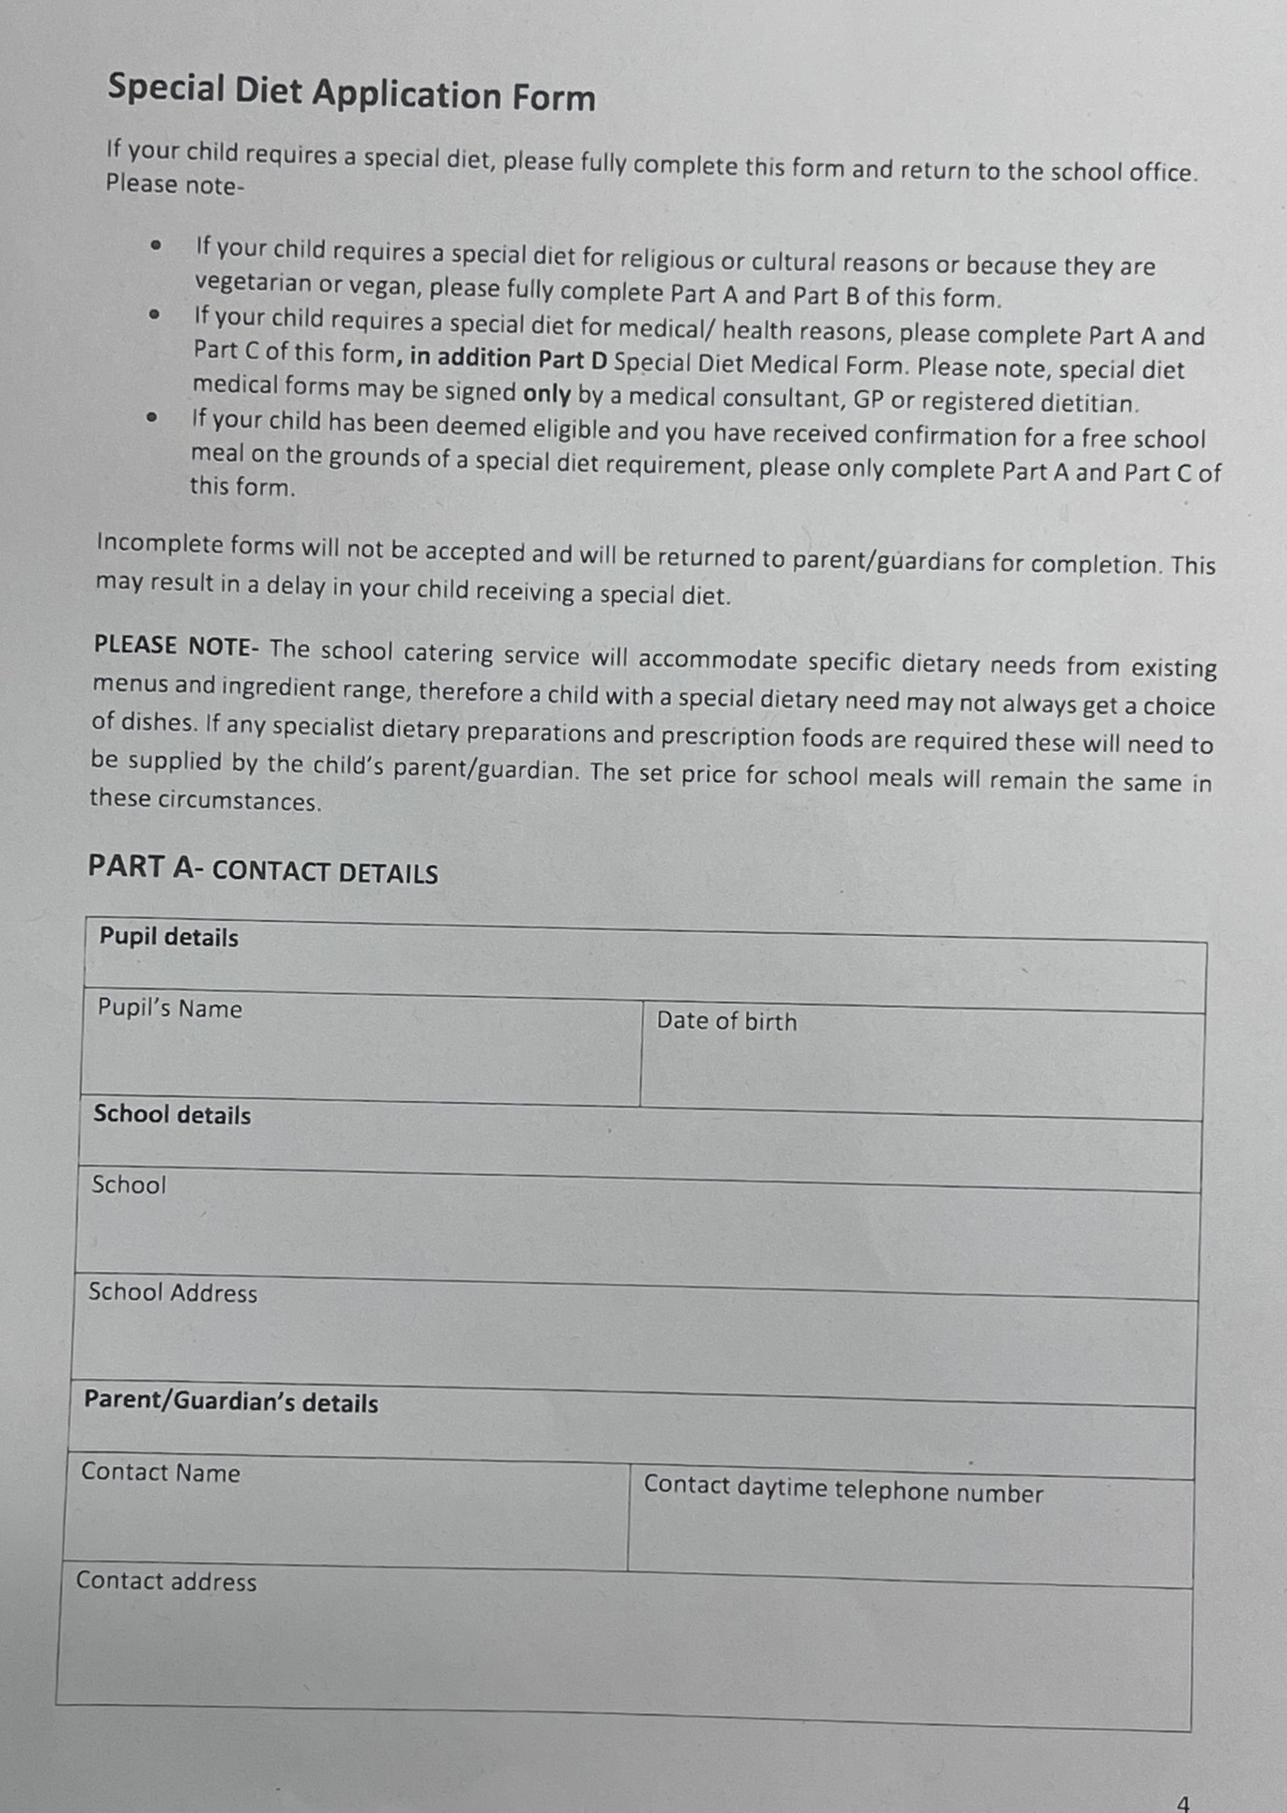

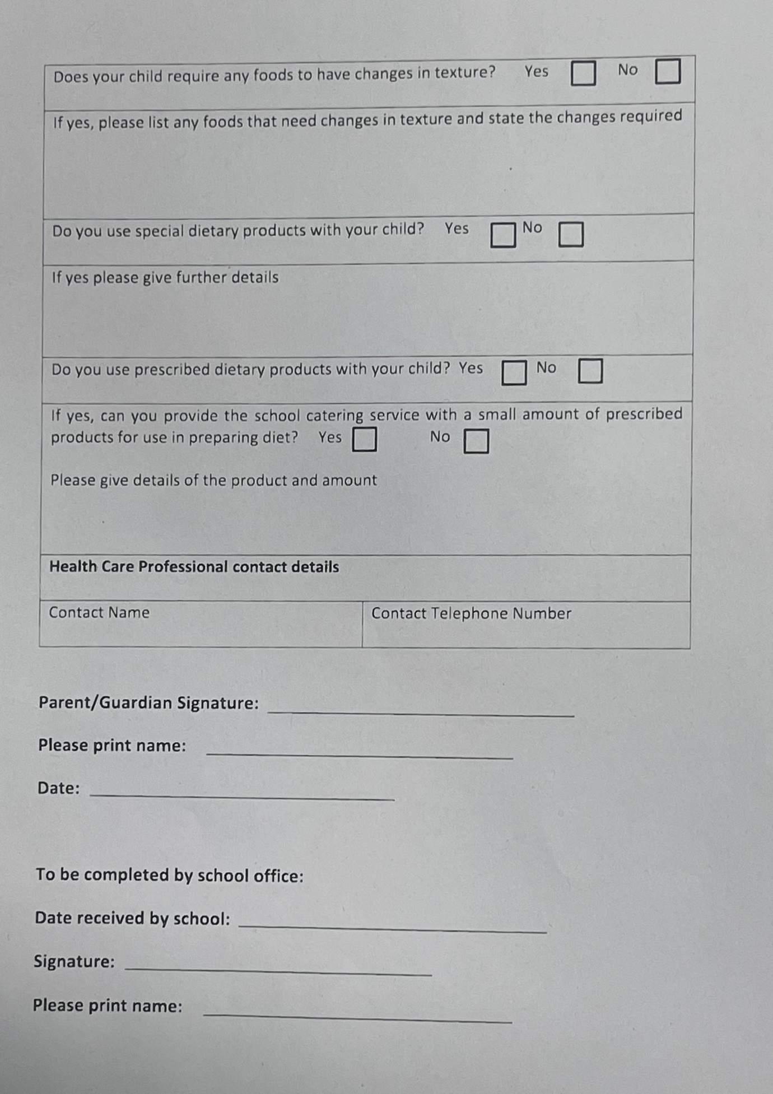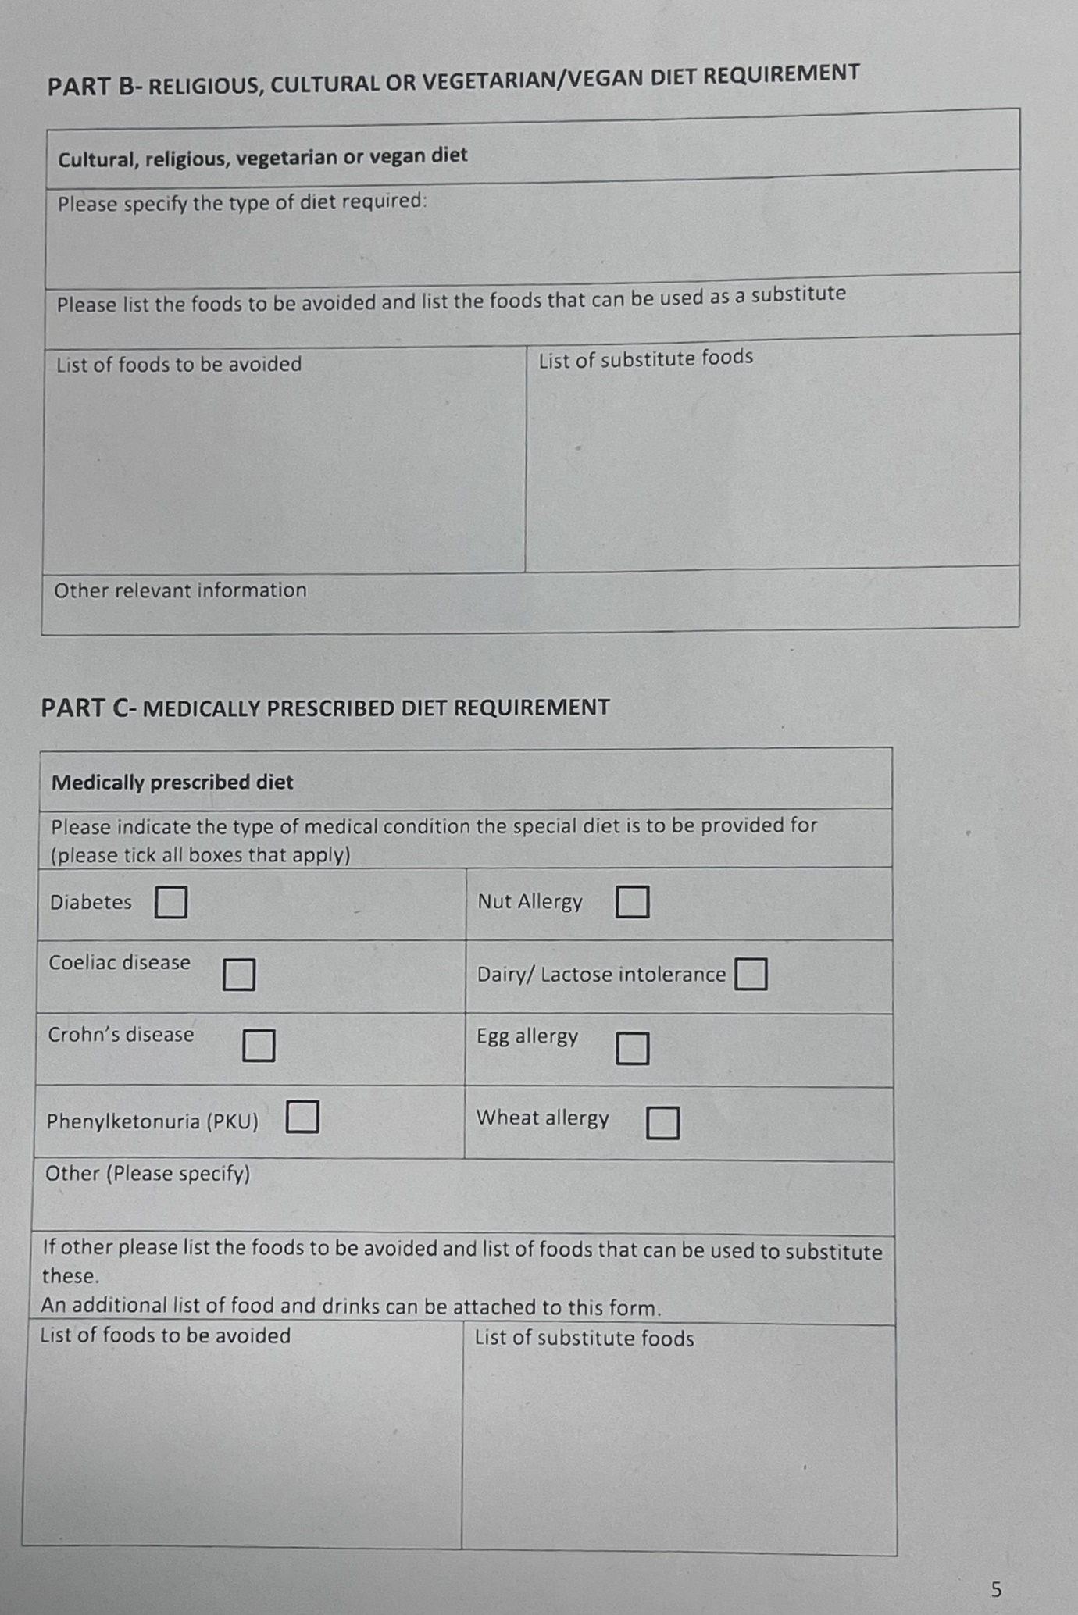
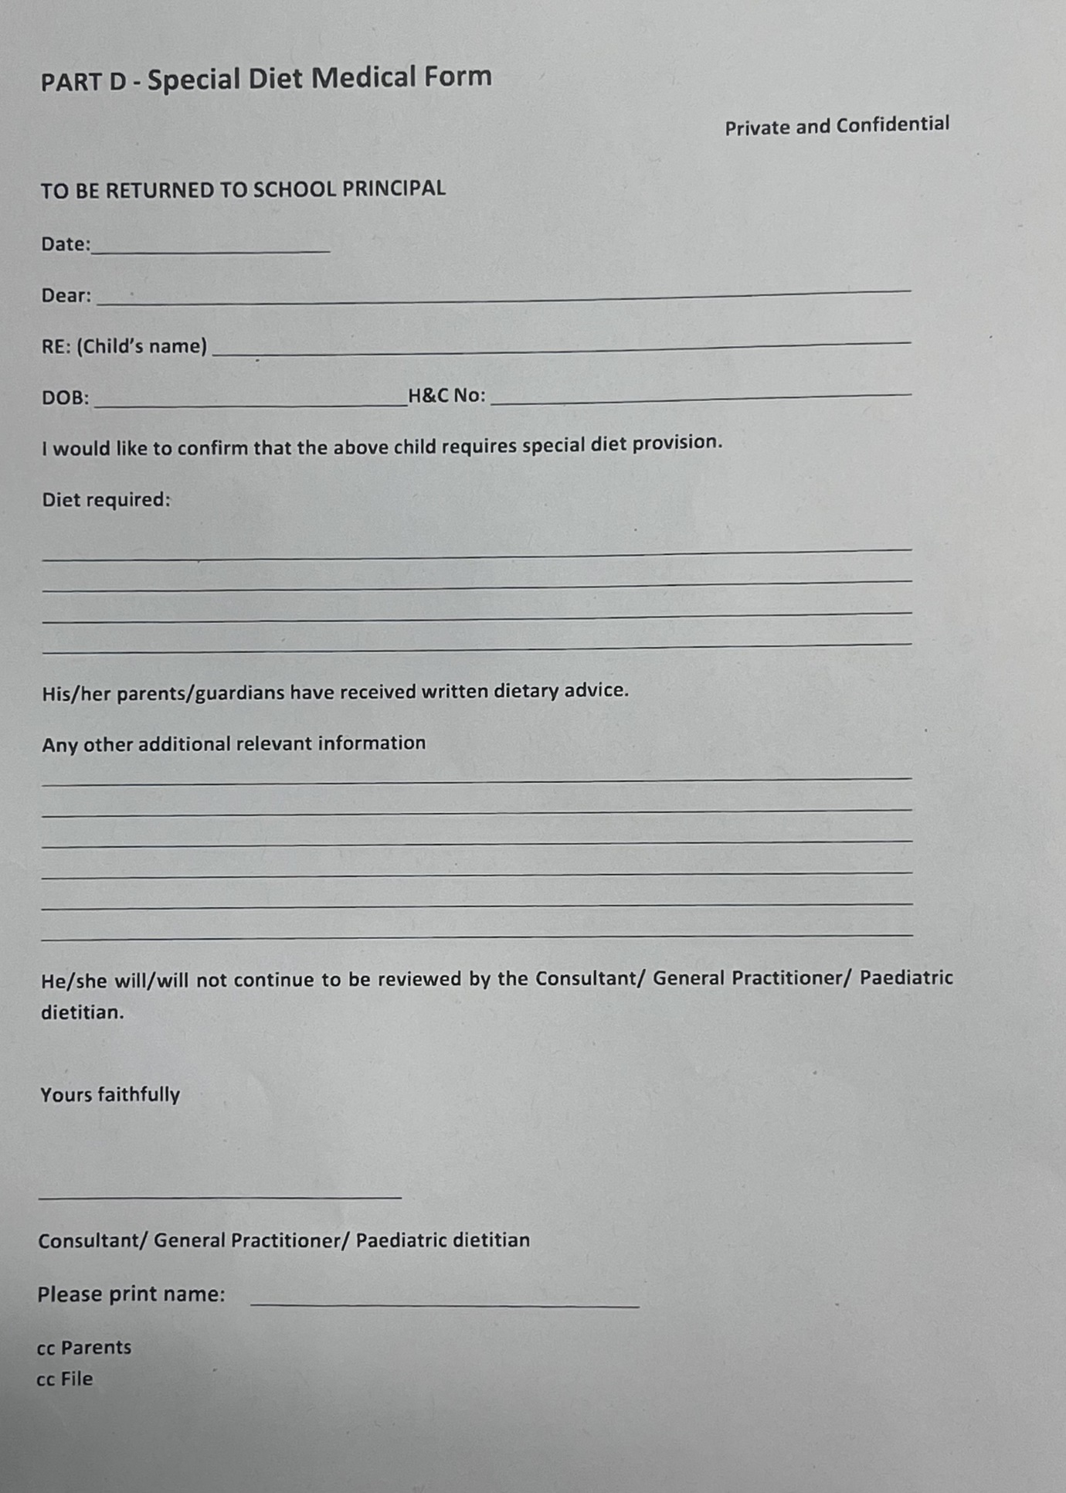

Parental Consultation occurred with a focus group made up from parents from P6A and P2B in February 2026. The parents responded as follows

Child’s Class4 responses

Primary 2B 3
Primary 6A 1
Have you reviewed the policies provided?4 responses

Yes 4
Partially 0
Not yet 0
4Overall, how clear do you find the updated policies? (1 = Not clear, 5 = Very clear)4 responses
Value Count
1 0
2 0
3 0
4 0
5 4
Do you feel the policies are appropriate and effective? (1 = Not effective, 5 = Very effective)4 responses
Value Count
1 0
2 0
3 0
4 2
5 2
Comments or suggestions on any policy (optional)
Please use this space to share any feedback on any of the following:
- Addressing Bullying Type Behaviour
- Drug Education Policy
- First Aid Policy
- Health & Safety Policy
- Parental Code of Conduct Policy
- Parental Complaints Policy
- Smoke Free Policy (including vaping)
2 responses
The policies are clear and comprehensive. However, the bullying behaviour policy would benefit from further clarification regarding the rights of a person experiencing bullying, particularly their right to defend themselves in situations involving physical violence.
Addressing bullying type behaviour policy. In the interventions 1-4 there is not much mention of what steps the school are taking with the pupil displaying the bullying type behaviour. I think this needs to be included and explained. Also there should be a procedure where the child's new teacher (following the summer break) is made aware of the previous bullying type behaviour... Especially if it is between pupils of the same class. Potentially even a meeting on the first week of school to check if anything happened over the summer break and/or if any reasonable adjustments are required in the classroom.
Do you feel this consultation gives parents a meaningful chance to contribute?4 responses
Yes 3
No 0
Unsure 1

