Drugs Education Policy


Holy Child Primary School
Belfast

(Updated March 2026)

Contents:
Section 1: Introduction Page 3
- Introduction Page 3
- Ethos & Statement Page 3
- Rationale Page 3
- Drug Definitions Page 4
- Aims of a Drugs Education Policy Page 4
Section 2: Development and Implementation Page 5
- Roles and Responsibilities Page 5
- Staff Training Page 5
- Overview and Aims of Drugs Education Programme Page 5
- Staff Use of Smoking and Alcohol Page 6
- Communicating the Policy to Parents and Other Relevant Agencies Page 6
Section 3: Management Issues Page 6
- Procedures for Managing Drug-Related Incidents Page 6
- A Range of Disciplinary Measures Page 6
- Confidentiality Page 6
- Procedures for Using Outside Agencies Page 7
- Emergency First Aid Page 7
- Guidance for Confiscation and Storage of Harmful Substances Page 7
- Guidance on Storage, Handling and Disposal of Hazardous Substances Page 7
Section 4: Monitoring, Evaluation and Review Page 7
Section 5: Appendices. Page 7
Appendices:
- Finding an illegal substance on Holy Child premises Page 8
- Pupil suspected of distributing an illegal substance Page 9
- Pupil suspected of taking drugs in Holy Child Primary School Page 10

Holy Child Primary School: Drugs Education Policy

Section 1: Introduction

a) Ethos Statement

At Holy Child Primary School we have a strong Catholic ethos and believe that the safety, welfare and personal development of everyone in our school community is of paramount importance.
We believe in maximising the spiritual, personal, academic and social potential of each pupil – we have high expectations that all pupils can and will achieve the very best of their ability.
It is our mission that we should develop in each pupil a deep-seated understanding of their duties and responsibilities as citizens. We aim to provide an environment in which fairness, respect, tolerance, compassion and forgiveness permeate all relationships.

The school’s vision is of Sharing, Caring and Learning.
Through Sharing
We share with friends, families and the wider community by showing good manners, respect and kindness.
We share responsibility by working in partnership with parents and stakeholders—because it takes a village to raise a child.
Through Caring
We care for everyone’s emotional, spiritual, social, physical and academic wellbeing.
We care for one another, our families, our parish, our community and our world.
Through Learning
We learn to be the best we can be, striving for high expectations and high standards for all.
We learn to grow in confidence, independence and a love of lifelong learning.

In order to achieve this, we aim to provide a caring, safe and welcoming school where each pupil is special and feels valued, supported and happy.

b) Rationale

The Board of Governors of each school is required by the Department of Education to establish and maintain a Drugs Policy. The school drugs policy is based on guidelines from DENI (Circular 2004/9) and has been developed as a response to the growing concerns about the use and misuse of drugs in Northern Ireland.
The policy endeavours to make a clear statement of our views on drugs and drug education. It ensures a consistent approach among staff on drugs education and in the handling of drug related incidents. Good practice for the future is also safeguarded.
We at Holy Child Primary School take a very serious view of drug related incidents. We recognise that there are those who are required to take prescribed drugs because of a health problem. We wish to develop a programme to ensure that pupils live in a drug free lifestyle.
Drug abuse is a whole community issue and we believe that the school has a role to play in conjunction with the other statutory and voluntary agencies within the community. The support of parents is vital, as the school needs the support of parents to extend the messages taught in the classroom into the home. Drugs education alone will not solve the problem of drugs abuse but the problems will not be solved in the absence of effective drugs education.
Drugs education is a cross-curricular issue whereby we seek to ensure that key messages are reinforced in all aspects of school life, which reflect the caring ethos of the school. We believe that drugs education needs to be part of a holistic learning approach aimed at the overall development of our pupils.

c) Drug Definitions

A drug is any substance which when taken has the effect of altering the way a person behaves, feels, sees or thinks.
Drugs include:
a) Illegal drugs-those substances listed as controlled drugs: Class A, B & C examples including heroin, cocaine, Ecstasy, cannabis and magic mushrooms.
b) Illicit drugs-include those socially unacceptable legal drugs. E.g. poppers, solvents and the underage consumption of alcohol and tobacco.
c) Prescribed drugs-those given by a doctor on prescription (also known as ‘over the counter drugs’) e.g. tranquillisers, sleeping tablets and strong painkillers.
d) The substances listed are examples covered by this policy. This is not an exhaustive list and other controlled or psychoactive substances may also be included.

d) Aims of Drugs Education Policy

a) To provide a clear statement of the school’s view on drugs education.
b) To ensure a consistent approach from staff to drugs education and in the handling of drug related incidents.
c) To safeguard good practice in the future.

Section 2: Development and Implementation

a) Roles and Responsibilities

The Board of Governors and Principal will have overall responsibility for ensuring the effective implementation of the Drugs Policy in Holy Child Primary School.
The Child Protection Team (Vice Principal and other designated teachers) will ensure an appropriate programme of study is being delivered for all pupils within the school. Duties will include:
a) Liaising with the Principal on the implementation of the policy.
b) Contacting and liaising with outside agencies.
c) Offering support and training where necessary for the Board of Governors, staff and parents on drug education matters.
d) Helping to promote an awareness of drug education within the school.

All other teaching staff will be responsible for putting into practice the policy and ensuring that appropriate lessons are taught to ensure that children are developing positive attitudes towards a healthy way of life. Non-teaching staff will support teachers where necessary and will report all drug related incidents to the Drugs Education Coordinator.

b) Staff Training

Periodically drug education programmes may be organised for staff to meet training needs, in order to implement the drugs education policy. This will take the form of ‘in-house’ training although specialist drug education staff may also attend in-service training to inform staff of new developments.

Parents will be informed about certain drug issues if appropriate by receiving information leaflets from the school produced by statutory agencies. Parents will also be encouraged to contact the school if they have concerns about drug issues.

c) Overview of Drugs Education Programme

Drugs education will be an integral part of our Personal Development and Mutual Understanding programme, incorporating the personal and social development of pupils in their environment. Aspects covered will be relevant to their age and will take account of their present knowledge and experience of drugs. Adequate and suitable resources will be used in lessons of Living and Learning Together. The approach adopted will be mainly preventative and teaching methods will include pupil centred activities e.g. role play, drama and group work. Where appropriate links will be made with other relevant areas of learning e.g. Religious Education, Physical Education and PDMU. On occasion outside agencies may be asked for specialist help. E.g. PSNI, nurse, etc. if this is the case the class teacher will remain with the children at all times.

Aims of your Drug Education Programme:
a) To promote positive attitudes towards personal health.
b) To inform pupils of the effects of drug use and abuse.
c) To help pupils build up the self-esteem of the pupils.
d) To help pupils acquire skills in managing the pressures of the youth culture in which they live.
e) To help pupils acquire decision-making skills.
f) To create a climate where a young person feels comfortable to discuss problems around substance misuse.
g) To encourage a participative approach in which each pupil is actively involved.
h) To encourage a healthy and critical respect for all substances taken into the body.
i) To equip pupils with skills that will empower them to take responsibility for their own health and safety.

d) Staff Use of Smoking and Alcohol
Holy Child Primary School is a smoke-free zone. This means there will be no smoking on the premises or outside any of the school doors. Consumption of alcohol is also not permitted during the school day.

e) Communicating the Policy to Parents and Other Relevant Agencies
The Drugs Education Policy will be made available to all new parents and in the event of the policy being updated new copies will be issued to all parents. A draft copy of the policy will be sent to parents at a consultation stage and responses will be taken into consideration before the policy is finalised.

Section 3: Management Issues
a) Procedures for Managing Drug-Related Incidents

For all those involved in dealing with incidents of drug misuse, the experience is likely to be traumatic. This will be true not only for the Principal, teachers, other members of staff and Governors of the school but also for the pupil involved in the incident, their parents and other pupils in the school. Dealing with suspected incidents of drug misuse will require extreme sensitivity on the part of those involved. During instances where a pupil or pupils are suspected of, or found in possession of drug, their names and identities will be passed on to the PSNI. Any suspicious substance found in school or in the possession of a pupil will also be given to the police for analysis. If a pupil is suspected of being under the influence of drugs parents will be notified immediately and appropriate medical action will be taken. Parents will be encouraged to make the school a drug free zone. Confidentiality in drug related incidents cannot be guaranteed. In cases where an incident has occurred and the school is approached by the press, a prepared written statement will be made, only by the Principal or his/her deputy. This statement will include the fact that the school is dealing with the incident. Pupils involved in the taking of drugs will be encouraged to attend counselling sessions.

b) A Range of Disciplinary Measures

The Board of Governors, Principal and staff have a duty to protect every pupil from the drug culture and will follow EA/DE procedures to protect all pupils from the danger of drugs. Pupils suspected of possessing, supplying or using drugs on the school premises will be dealt with in a serious manner. Incidents involving drugs may lead to suspension, after investigation of the incident and in extreme cases expulsion may be recommended. The school in these cases will act in accordance with DE and EA Guidelines.
The school expects parents to support these measures and to cooperate with the school in encouraging the child to lead a healthier lifestyle. Parents need to be aware of the school’s discipline policy on drugs as:
- It reassures parents that the school treats drug related matters very seriously, thus providing protection for pupils.
- It informs parents on what to expect if their child becomes involved in a drug related incident.

At all times the needs of each individual child involved in such incidents will be considered and appropriate intervention and support mechanisms will be put in place.

c) Confidentiality

Confidentiality can never be guaranteed to any pupil. Any criminal activity disclosed must be passed on to the designated teacher, PSNI and EA.

d) Procedures for Using Outside Agencies

If an outside agency is to be used the following checklist will be consulted:

- Does the individual/agency have a specified Child Protection Policy?
- How will the issue of confidentiality be dealt with?
- Are the teaching resources being used appropriately?
- Has the individual/agency worked with any other schools?
- Does the individual/agency have a clear set of aims and objectives as well as lesson plans?
- Has the individual/agency read the school’s Drugs Policy and are they prepared to adhere to it?
- Do parents/guardians know that an individual/agency is being used by the school?
- Will the input by the individual/agency be monitored?
- Will the pupils be asked how the session/class with the individual/agency went?
- Can the school terminate the work of the individual/agency if the classes or sessions are deemed inappropriate?
- Are evaluations carried out by the individual/agency and if so will the school have access to them?

e) Emergency First Aid

Ref. Appendix 3

f) Guidance for Confiscation and Storage of Harmful Substances

If a harmful substance is found it will be stored in a secure place and the relevant authorities notified as outlined in Appendices 1-3.

g) Guidance on Storage, Handling and Disposal of Hazardous Substances

Within many classrooms materials are required and used which are toxic and emit intoxicating fumes e.g. solvent-based glues, aerosol sprays, paint thinners, felt-tipped pens. These materials will be kept to a minimum and need to be carefully monitored and stored in locked cupboards to which only staff have access. Classrooms where such materials are used will be kept in locked cupboards when not in use. Materials of a similar nature which are used by caretakers and cleaning staff will be kept in locked storerooms and used with care.

Section 4: Monitoring, Evaluation and Review
The drugs education policy and programme will be monitored and reviewed on a regular basis as part of the School Development Plan to take account of the needs of staff and pupils. It will also be reviewed in light of particular incidents or local circumstances. Account will be taken of the views of the Board of Governors, staff, parents and pupils and any necessary changed will be made.

Section 5: Appendices

• Appendix 1: Finding an illegal substance on PPS premises.
• Appendix 2: Pupil suspected of distributing an illegal substance.
• Appendix 3: Pupil suspected of taking drugs in PPS.

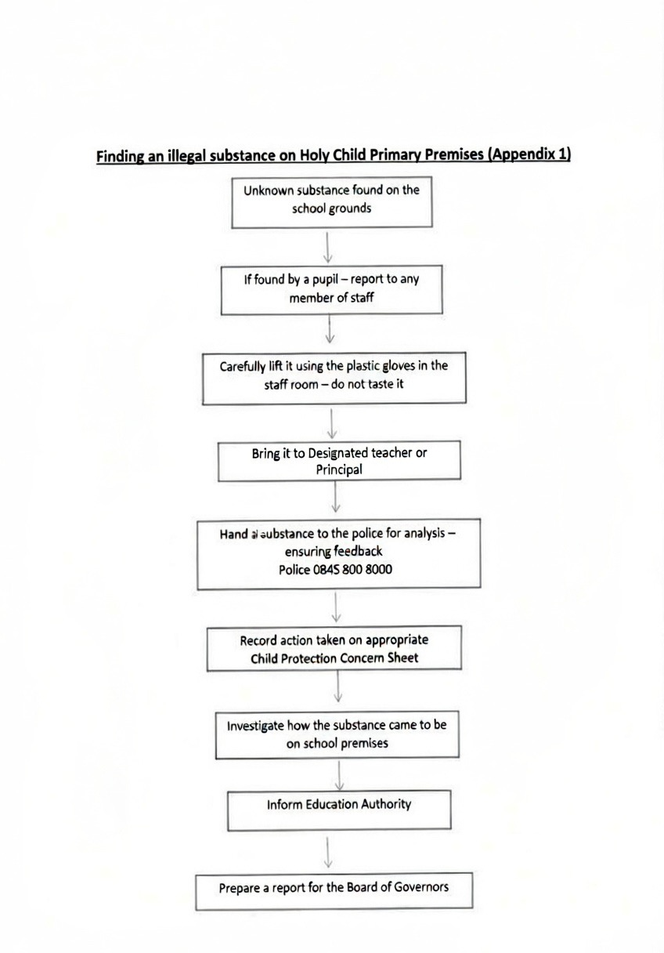

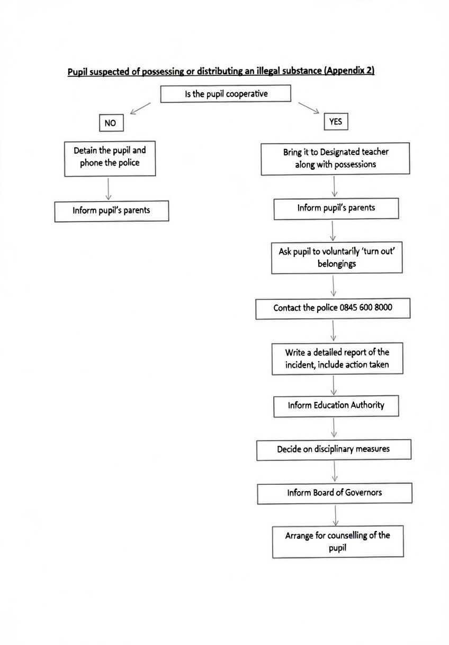

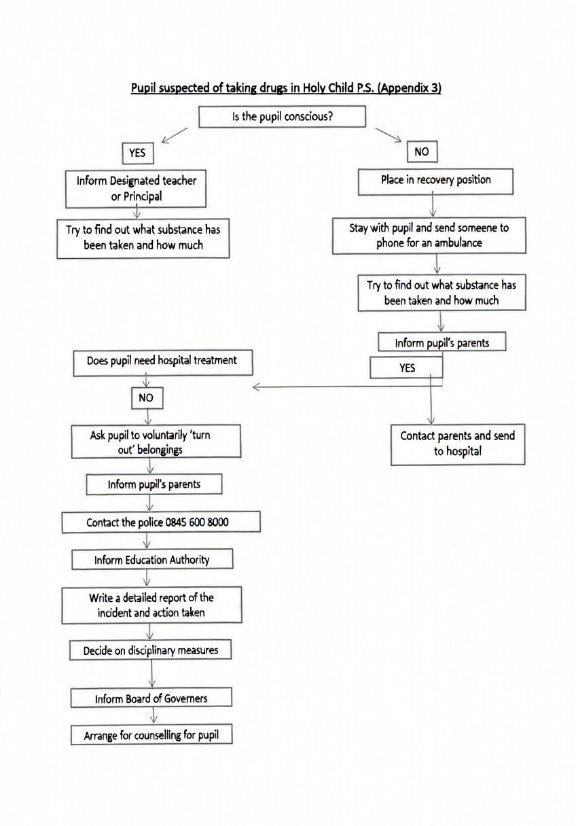

Parental Consultation occurred with a focus group made up from parents from P6A and P2B in February 2026. The parents responded as follows

Child’s Class4 responses
Primary 2B | 3
Primary 6A | 1
Have you reviewed the policies provided?4 responses
Yes | 4
Partially | 0
Not yet | 0
4Overall, how clear do you find the updated policies? (1 = Not clear, 5 = Very clear)4 responses
Value | Count
1 | 0
2 | 0
3 | 0
4 | 0
5 | 4
Do you feel the policies are appropriate and effective? (1 = Not effective, 5 = Very effective)4 responses
Value | Count
1 | 0
2 | 0
3 | 0
4 | 2
5 | 2
Comments or suggestions on any policy (optional)
Please use this space to share any feedback on any of the following:
- Addressing Bullying Type Behaviour
- Drug Education Policy
- First Aid Policy
- Health & Safety Policy
- Parental Code of Conduct Policy
- Parental Complaints Policy
- Smoke Free Policy (including vaping)
2 responses
The policies are clear and comprehensive. However, the bullying behaviour policy would benefit from further clarification regarding the rights of a person experiencing bullying, particularly their right to defend themselves in situations involving physical violence.
Addressing bullying type behaviour policy. In the interventions 1-4 there is not much mention of what steps the school are taking with the pupil displaying the bullying type behaviour. I think this needs to be included and explained. Also there should be a procedure where the child's new teacher (following the summer break) is made aware of the previous bullying type behaviour... Especially if it is between pupils of the same class. Potentially even a meeting on the first week of school to check if anything happened over the summer break and/or if any reasonable adjustments are required in the classroom.
Do you feel this consultation gives parents a meaningful chance to contribute?4 responses
Yes 3
No 0
Unsure 1

